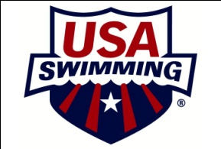
Talent Release Form

Talent Name: ____________________ Project Title: ___EZ Diversity Summit____
I hereby consent without further consideration or compensation to the use (full or in part) of all videotapes taken of me and/or recordings made of my voice and/or written extraction, in whole or in part, of such recordings for the purposes of illustration, broadcast, or distribution in any manner. I hereby authorize the reproduction, sale, copyright, exhibit, broadcast, electronic storage and/or distribution of said photographs/video tapes/electronic representations and/or sound recordings without limitation at the discretion of USA Swimming.

I understand that USA Swimming owns the copyright in the project and has the exclusive right to use the project in whatever way it wishes. I waive any rights of privacy and/or publicity that I might otherwise have with regard to the Production and any derivative work of the Production, including any promotional materials in connection with the Production. No use of my name, voice and/or likeness shall be the basis of any future claim of any kind against USA Swimming, its parent, subsidiary and affiliated companies, the officers, directors, agents or employees of any of these, or their successors or assigns, nor shall this release be made the basis of any such claim. I represent that I am at least eighteen (18) years old, that I have read and fully understand the terms of this agreement, and that I have the right to enter into this agreement.
Talent's signature__________________________________________________
Parent or Guardian if under 18 _______________________________________
Address ________________________________ City _____________________
State ____________________ Zip code _____________
Date: ____/____/____

